**Return on Investment**

During the booting in retailing industries over couple decays, Macy*s covers most first-tier and second-tier city over the United States, and constructs 19 flagship stores which provided the highest revenue and attract most amount of consumer’s attention. This strategy plans to distribute both of 3D virtual digital mirror and 3D body scanner in each flag stores.

|  |  |  |  |
| --- | --- | --- | --- |
| Price | 3D Body Scanner (K USD) | Digital Mirror (K USD) | Total (K USD) |
| Each Flag Store | 40 | 6.4 | 46.4 |
| Total 19 Flag Store | 760 | 121.6 | 881.6 |

Table 5.4.1 Cost analysis for system

As shown in the table above, the estimated total cost for 19 flagship stores is about 0.9 MM (million) USD for both of the 3D Body Scanner and Digital Virtual Mirror. The detail price list of potential suppliers of 3D Body Scanner can be found in Appendix I.

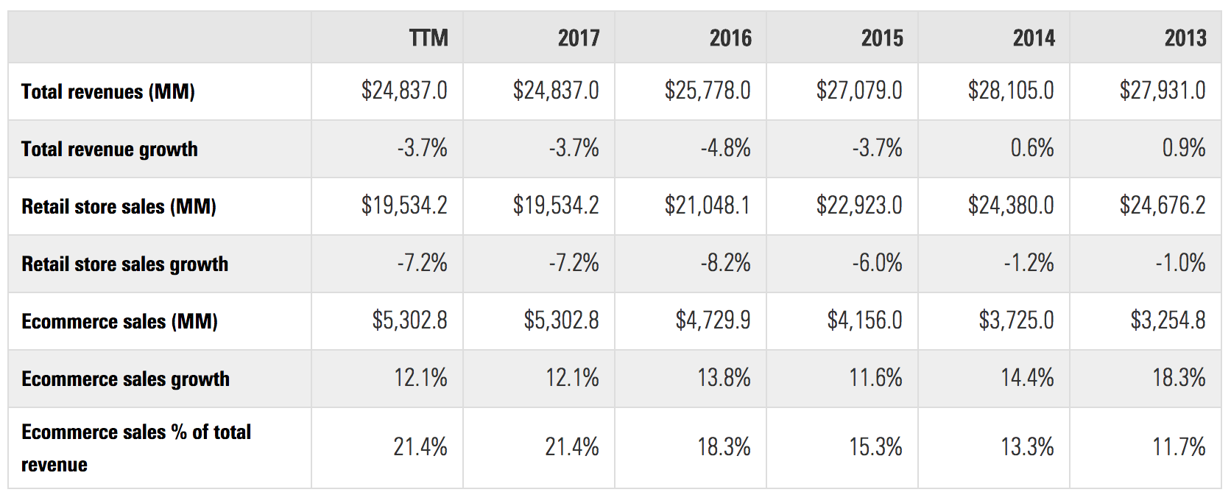

Table 5.4.2 E-commerce sales of Macy*s quarterly in the latest financial year

From the ecommerce sales growth from 2013 to 2017, this strategy estimates the growth on 2018 is the same as the average growth, 13.71%. This is about 6030.16 MM USD. As the suppliers of 3D Body Scanner stated, the digital technology will boot the sales about 3%, about 180.91 MM USD. The Profit is 116 MM.

|  |  |  |
| --- | --- | --- |
| Gain on the Investment (MM) | Cost of investment (MM) | ROI |
| 15.196021848 | 0.9 | **15.88446872** |

Table 5.4.3 Return on Investment

This table indicate the return on investment on this system, which is about 15.88% in the first year. w

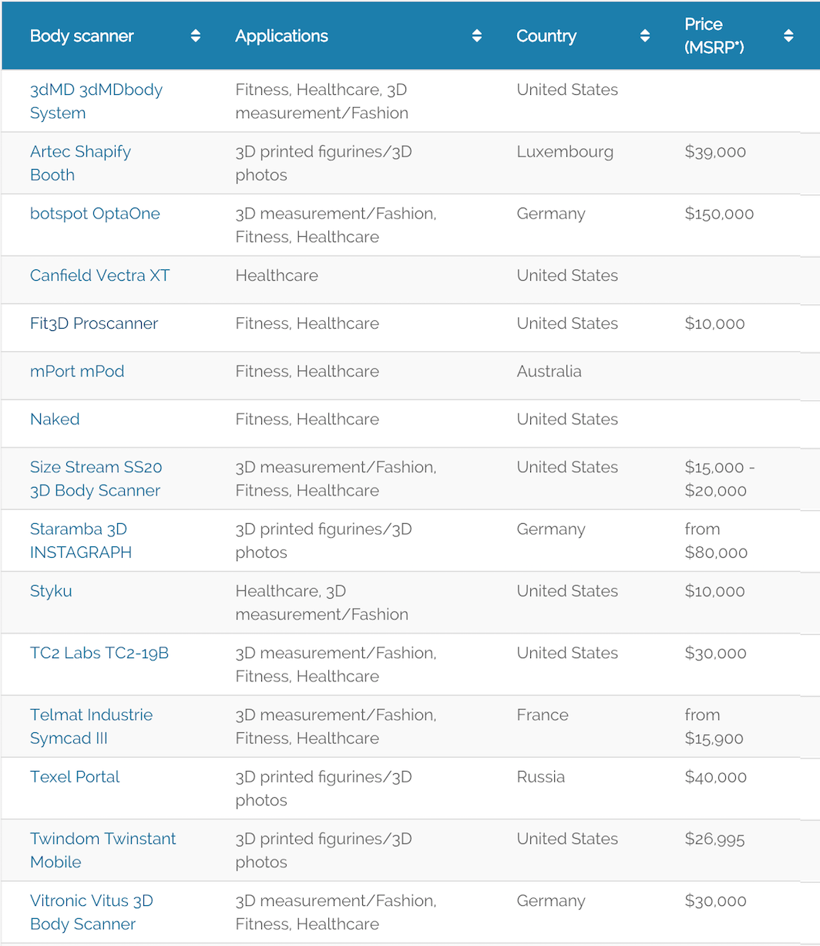

Digital mirror:

<https://www.aliexpress.com/item/3D-Kinect-Virtual-Dressing-Mirror-Virtual-Fitting-Room-42inches/956281641.html>

digital scanner:

<https://www.aniwaa.com/best-3d-body-scanners/>

Macy’s ecommerce growth rate

<https://www.bloomberg.com/gadfly/articles/2017-11-09/macy-s-needs-to-sharpen-its-fuzzy-e-commerce-strategy>

<https://retail-index.emarketer.com/company/data/5374f24c4d4afd2bb44465c7/5374f29b4d4afd824cc15c53/lfy/false/macys-revenues-sales>